**1 Colour Theory**

1. **Red:** Energy, intensity, love.
2. **Yellow:** Attention grabbing, joy and intellect. Not good for something that has to be looked at for a long time.
3. **Green:** Freshness, safety, control.
4. **Blue:** Trustworthy, stability, trust, serenity.
5. 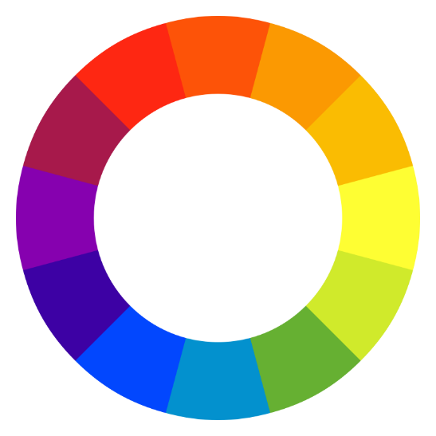**Purple:** Royalty, Wealth, Femineity.

**Combination of colours:**

1. **Analogous Colours:** Take two colours which are right next to each other to create a harmonious merge.   
   Logo, background, navigation bar.
2. **Complementary Colours:** To grab attention or to pop out more. Do not **style text with complementary colours.** Keep it to things like ICON, LOGO, etc.
3. **Adobe Colour Website –**Allows us to pick colours as per the mood of your website. You can choose square, triangle, equivalent etc to pick combinations of hex codes.
4. **Colourhunt Website-** Use this to pick palllets.

**2 Typography:**

1. **Serif:** have feat around their central beams. They are inspired by marvel carvings of history. **Serious, authoritative, older, magazine, letterhead etc.**
   1. Old style, transitional modern and slab serif.
   2. Note the difference between thickest and thinnest part of letters the newer ones have this exaggerated. MODERN SERIF in VOGUE.
2. **San-serifs:** Sensible, simple, kind, approachable.
   1. Grotesque(New Gothic), Neo-Grotesque(Helvetica), Most readable 🡪**Humanist**(Gill Sans, Verdana), Geometric(futura).
   2. Used for body text as it is more readable and more understanding.
3. Stick to 2 fonts only for a given design. It makes it look cleaner and tighter. Find fonts which have **similar** mood and time era. What you can **contrast** is – weights, serifness.
4. **Never use-** Comic Sans, Kristen, Papyrus, Viner, Curlz.
5. **Legibility of fonts:**
6. Open Shapes
7. Ample intercharacter spacing
8. Unambiguous forms
9. Varying proportions.

**3 UI Design and attention**

1. **Hierarchy:** 
   1. Colour – Highlight the one which are important and use muted colours for everything else.
   2. Size – Highlight using bigger size.
2. **Layout:** Create interest by using different shapes and sizes. Wikipedia pages are very bad design pages. Only keep **40-60 characters per line.  
   Chop** your content into different sections.
3. **Alignment:** Shift the starting points to be same for things which fall under same group. **Reduce the number of alignment points.** Make it coherent by using grid lines in mind to align as it makes it look more readable, professional, and speed to grasp the information.
4. **Whitespace:** Space things out to make everything look less cluttered and don’t bombard people with information. Make it clear and concise. Whitespace adds classiness in design.
5. **Audience:** You must know your audience. Know what appeals to the target audience otherwise it might backfire.

**4 User Experience Design:**

1. Simplicity – **Chop up the content make it simple.**
2. Keep your design and functionality consistent.
3. Reading patterns: The F Pattern. JUST LIKE F SHAPED OBVIOUSLY.  
    The Z pattern. Sometimes this is also used.
4. All Platform Design: Mobile responsive website is very important. How do you use the available space when it is being rendered on landscape pc while portrait mobile. Do not make it look like picture as well, as this will make your mobile screen just scroll a lot.
5. Do not use your Powers for EVIL? DARK PATTERNS. Do design in a way that makes people do what you want them to do instead of letting them do what they want to.  
   Highlighting premium options so much that makes people reuse it. Basically do not trick people by placing a hair on ad of screen.